Designing of Systems Science lab using SLP

Krati Saxena Neha Singh Chauhan
Centre of Excellence in System Science
Indian Institute of Technology (IIT), Jodhpur

ABSTRACT

The objective of this term paper is to design laboratories of Systems Science using Systematic Layout Procedure (SLP) algorithm. The need for proper planning of the labs is to minimize work and information flows, volume of work flows, and time. After a detailed analysis of what is required, and how the layout should be carried on, relationship chart, activity relationship diagram, space relationship diagram, etc are prepared. The final layouts are adjusted by trial and error until a satisfactory adjacency pattern is obtained.

INTRODUCTION

Systematic Layout Planning (SLP) was developed by Richard Muther (Muther,1961) [1] . SLP is a relatively simple process that objectively handles a multi-criteria evaluation process. According to the many researchers, plant layout is one way to reduce the cost of manufacturing and increase the productivity. It also increases good workflow in production route. The case study reported here illustrates the designing of laboratories by using SLP. Systematic Layout Planning develops a feasible plan of action through a multi-step procedure. SLP ensures that there is no wasted time in movement of people and materials between the labs, and no useless area in the building. In the progression of working through these steps a great deal of process understanding is required. SLP algorithm will be able to develop a vastly improved lab designs, improving process speeds, reducing the movement/travel time, reducing the labor for material movement and improving the work process understanding.

CENTRE OF EXCELLENCE IN SYSTEMS SCIENCE @ IIT JODHPUR

A Centre of Excellence (CoE) in Systems Science (SS) is established to promote a new academic interdisciplinary engineering education and research program for a sustainable future.
Over the last hundred years as human thought process has developed, a systems science approach to dealing with problems has started taking shape. This viewpoint envisages looking at a system: be it a mechanical one, like an automobile or a living organism such as humans, not as an individual entity but as interconnected systems which work in tandem to provide a bigger picture; sometimes called the ecologic viewpoint. The key words are: connectedness, relationships and context. Thus a bigger system composed of smaller sub-systems evolves by the interactions between the smaller sub-systems arising from self-organization between them. This is very pertinent to the present context as one of the major problems of our time, such as the environmental issue cannot be understood in isolation: they are interconnected and interdependent.
Thus a systems approach to these problems is needed. Viable solutions are those that are sustainable, they satisfy present needs without hampering the resource availability for the future. The key features of systems thinking are: a shift of paradigm from the part to the whole and the ability to use concepts alternatively at the systems level. At the same time, different system levels represent levels of differing complexity. At each level the observed phenomena exhibit properties that do not exist at lower levels. Thus the system properties of a particular level are called emergent properties: they emerge at that particular level. This was made spectacularly clear in the first quarter of the last century with the

development of quantum physics in which the emergent properties were very different from those of the familiar classical world.
Following are a few major concerns that are addressed in the systems science research at CoE
- Engineered systems and manufacturing processes are becoming increasingly complex, and their cost effectiveness needs to be addressed.
- Rigorous mathematical frameworks that give a deeper insight in the design of new materials and processes with prescribed functional properties.
- Investigate the isomorphism of concepts, laws and models in various fields of science, and to help in transforming relevant information from one field to another.
- Societal concerns have led to regulatory actions that reflect more stringent requirements for the safety and reliability of products; they demand new methods for forecasting and quantification of uncertainties.
- The useful integration of large data requires that it be processed, preferably in real time, and transformed into information and knowledge.
- Keeping in mind that Globalization, awareness of resource limitations, increasing sensitivity to anthropogenic effects on the environment the CoE in SS would continually analyze and evaluate its activities in a broader social context, beyond the basic concerns presented above.
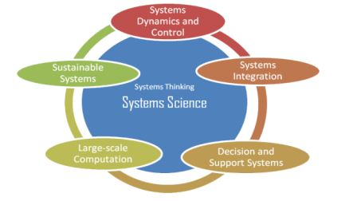
The CoE in SS facilitates the development and use of Mathematical techniques in variety of situations that appear in variety of Systems. The CoE also provides the concept of “Systems thinking” that enables one to do multidisciplinary and integrated systems design.
SYSTEMATIC LAYOUT PLANNING: INTRODUCTION

SLP (Systematic Layout Procedure) involves-
- Developing a relationship chart showing the degree of importance of having each department located adjacent to every other department.
- From the chart, an activity relationship diagram, similar to the flow graph used for illustrating material handling between departments, is developed.
- The activity relationship diagram is then adjusted by trial and error until a satisfactory adjacency pattern is obtained. This pattern, in turn, is modified department by department to meet building space relationships.

Here all the inputs will not be used. For example, in the designing of labs, Volume of work flows and sequencing of work has not much significance. So these inputs are not considered while preparing the layout. Only work and information flows and critical issues of timing is considered.

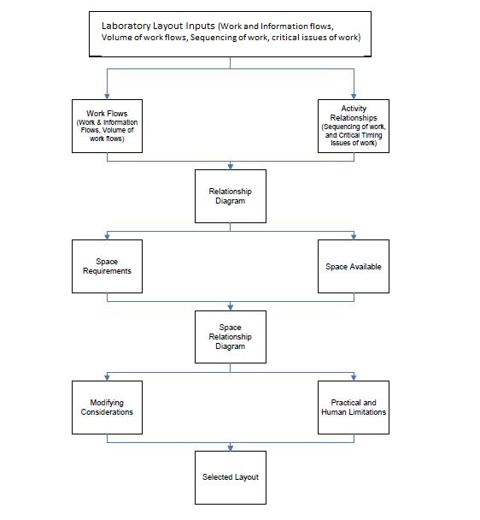

In a nutshell,
- All layout planning rests on the three fundamentals of:
1. Relationships between the activities in the layout.
2. Space for each activity area, in amount, kind, and shape.
3. Adjustment of relationships and space into an effective plan.
- By applying the three fundamentals (in the order shown below)- the planner assures beeter decisions and layouts.

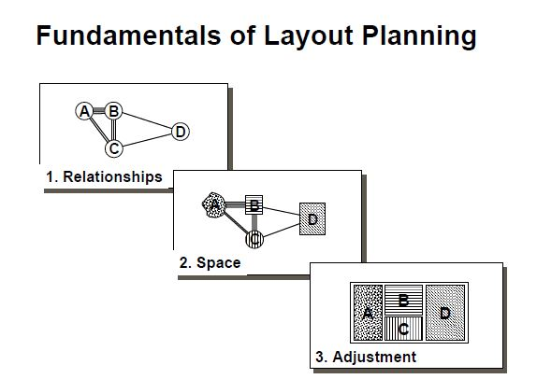

SLP IN LAB LAYOUT PLANNING-

The assumption of space available is 7000 sq.ft. And 25% of this space is free for uninterrupted movement of people and materials.
According to the course structure, it is concluded that there will be requirement of total 7 labs which are categorized as follows:
- Embedded Systems lab
- Robotics and control Lab
- Systems Designing lab
- Finance lab
- Complex Networks lab
- R&D center
- Computer center

ACTIVITY RELATIONSHIP DIAGRAM-
Value | Closeness
A | Absolutely Necessary
E | Especially Important
I | Important
O | Ordinary
U | Unnecessary
X | Undesirable
Code | Reason
1 | Flow of materials
2 | Ease of supervision
3 | Convenience

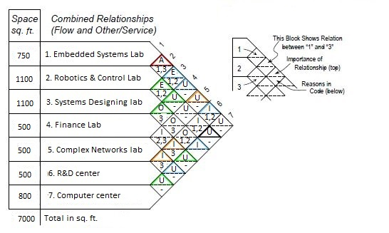

RELATIONSHIP DIAGRAM
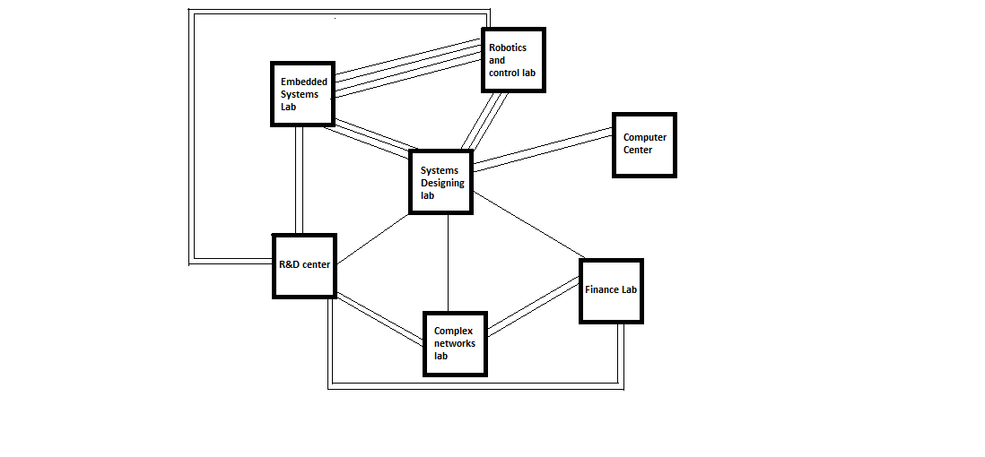

Convention Used-
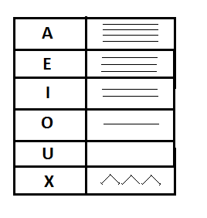

SPACE RELATIONSHIPS AND LAYOUT
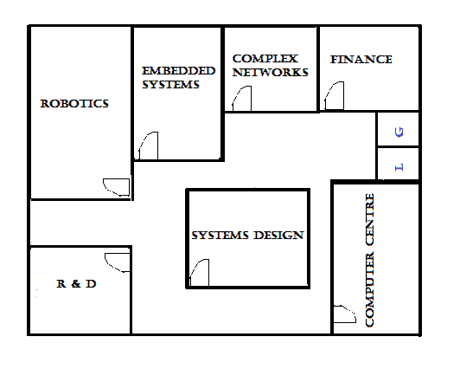

CONCLUSION

As shown above,layouts are prepared according to the SLP algorithm. Based on the Relationship Diagram showing degree of importance between various departments, we end up with the above final Space Relations and Layout. This layout will finally result in less time consumption in movement of materials and people. Work and information flow takes place properly.

REFERENCES

[1] R Muther, “Systematic Layout Planning”, Mc Graw 1955
[2] “Construction Office design with systematic layout planning” by James P. Gilbert
[3] www.google.com
[4] Wikipedia

